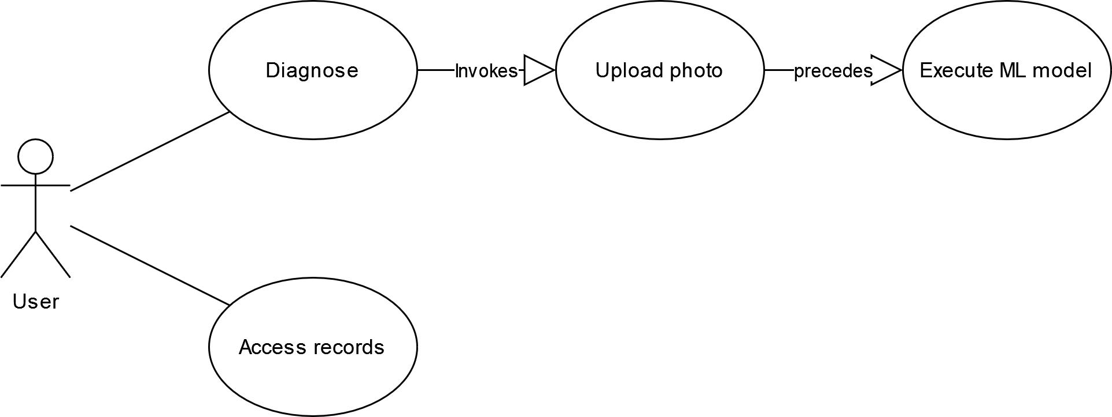

Use case 1: Diagnose

Base course: The user clicks the Diagnose button. The system then shows the Uploading Photo page with two options: via camera or via file upload. The user selects one of the two options and uploads a photo. The system then runs the ML model and displays the diagnostic results with scores for each class (or top three classes).

Use case 2: Access records

Base course: The user clicks the View Records button, then enters the name of the patient. The system then displays the records of the selected user.